**Abstract**

In healthcare environments like hospitals and clinics, staff adherence to hand hygiene standards is crucial.

It is one of the best methods for reducing infections linked to healthcare.

The effectiveness of each episode of hand washing is also crucial, and it can be achieved by following some established recommendations like one given by the World Health Organization (WHO).

The recommended method for washing hands involves massaging the hands in various ways to make sure that no part of the hands is missed.

Surgical site infections threaten the lives of millions of people each year because hospitals fail to follow adequate hand washing instructions before operations are performed by staff members (SSI). Antibiotic resistance would spread as a result of these infections.

By observing the various hand washing strategies recommended by the World Health Organization, we develop an automated smart hand washing system to prevent surgical site infections and lower the number of illnesses that pose a threat to human life. It will be simple for the Hospital Infection Control Committee to monitor each individual by maintaining the appropriate database.

On a real-time basis, this project is being tested.

3

# Chapter 1. Introduction

**1.1 Introduction**

Hand Hygiene is extremely important in healthcare settings like hospitals and clinics. World Health Organization (W. H. O.) has given some standard guidelines for proper handwash. The quality of each hand washes is also important. According to guidelines, proper hand washing procedure contains different ways of hand wash procedures to ensure that no area of the hand is missing.

In hospitals, before operation a staff present with doctors does not follow proper handwash guidelines, hence every year millions of lives are threatened by Surgical Site Infections (SSI).

Surgical Site Infections (S. S. I.) are occurred during the surgery.

To avoid the Surgical Site Infections (S. S. I.) minimum 3 minutes are necessary to wash the hands properly by using the standard guidelines provided by the World Health Organization.

To ensure the complete hand hygiene World Health Organization has provided 6 different hand wash procedures to wash the hands properly.

# Chapter 2. Literature Survey

**2.1 Literature Survey:**

Table No.1: Literature Survey

|  |  |  |  |  |  |
| --- | --- | --- | --- | --- | --- |
| **Sr no.** | **Title of the paper** | **Author’s**  **name** | **Journal/**  **Conference**  **title** | **Year** | **Findings** |
| **1.** | RFID  Based  Hand  Hygiene  Compliance  Monitoring  Station | M. Akif Meydanci | IEEE  International  Conference on  Control  System. | 2013 | *Infection control strategy  *Use of acute care facility  *Cloral tolerability and skin colonization.   * antiseptic formulation * modes of delivery * short-term tolerability |
| **2.** | A System  for  Monitoring  Hand  Hygiene  Compliance based-on  Internet-of-  Things | Mert Bal and Reza  Abrishambaf | Journal of in  Infection control | 2017 | *Machine learning in electronic monitoring of hand hygiene   * retrospect analyze characteristics of patients * The patients were divided into concurrent and sequential groups * corticosteroid therapy * sequential organ failure * antigen test before each work shift |
| **3.** | Systems for  Monitoring Hands  Hygiene of  Medical  Staff in  Hospitals | Repanovic Cotoros.1 | The 8th IEEE  International  Conference on E-Health and  Bioengineering | 2020 | *Detection rate of bacteria.  *visually analyze the result by UV lamp   * Identification by RFID module * Disinfection technique.   *mechanism of actions   * antigen test before each work shift |

**2.2 Gaps Identified:**

1. Percentage criteria using real time feedback is not useful in Emergency situation where person has to wash his/her hands for less than 3 minutes.
2. Complete monitoring is not sufficient because if a user fails to complete the current hand pose then the system moves to the next hand pose, therefore output of the system is not efficient.
3. Hand remainder system is failed to detect the proper hand positions and also 3 minutes guidelines are not followed.

# Chapter 3. Aim and Objectives

**3.1 Aim:**

We build an automated smart handwash system to avoid the Surgical Site Infections and reduce the lives threaten infections by monitoring the different handwash techniques provided by the World Health Organization. By maintaining the proper database, it will be easy for Hospital Infection Control Committee to monitor the individual person.

**3.2 Objectives:**

To develop the smart hand wash system which will monitor the hand hygiene.

This System will record the time spent by the individuals before and after the Surgeries.

In the emergency situations this system will help to increase the efficiency of hand hygiene in minimum time.

By using the Database, we can record the time spent by the individual doctor before and after the surgery by following the proper guidelines provided by the World Health Organization.

# Chapter 4. System Specifications and Block Diagram

**4.1 System Specifications**

**4.1.1 Data Collection:**

Table No.2: Specification of Data Collection

|  |  |  |
| --- | --- | --- |
| Sr. No | SPECS | DESCRIPTION |
| 1 | OpenCV | Specific algorithms can be used to detect and recognize human body parts. |
| 2. | Pandas | Pandas is defined as an open-source library that provides high-performance data manipulation in Python. |
| 3. | Matplotlib | Matplotlib is a comprehensive library for creating static, animated, and interactive visualizations in Python. Matplotlib makes easy things easy and hard things possible. |
| 4. | NumPy | NumPy is a Python library used for working with arrays. It also has functions for working in domain of linear algebra, Fourier transform, and matrices. |

**4.1.3 Model Specifications:**

Table No.4: Specification of Model

|  |  |  |  |
| --- | --- | --- | --- |
| Sr.No | SPECS | DESCRIPTION | MODEL SPECS |
| 1. | Loss and Cost  Function | A single record's difference between actual and predicted values is captured by the loss function, while the difference | Mean – Squared Error |
| 2. | Epoch | The term "epoch" is applied to the number of passes the machine learning algorithm has made across the full training dataset. | The Epoch used in the model is 100. |
| 4. | Optimizers | You can modify your weights and learning rate using various optimizers. However, the application determines which optimizer is better. | Used Optimizer -Adam |
| 5. | Hidden Layers | Hidden layer(s) are the secret sauce of your network. They allow you to model complex data thanks to their nodes/neurons. They are ―hidden‖ because the true values of their nodes are unknown in the training dataset. | Hidden Layers used are - 50 |

**4**

**:**

**Block Diagram**

**.2**

Fig No.

1:

Block Diagram

The block diagram up above

demonstrates the

entire model's approach to process the input image data

set and give out rele

vant output as per our predictions

.

The

image

data set, a required element for the prediction, comes first in the block diagram.

The next block, "Machine Learning," indicates that deep learning, which results in a variety of

algorithms using neural network

s, is the primary technology employed in this context.

A branch of machine learning called "deep learning" offers a variety of methods that enable machines

to think like people.

The C

NN block comes next. This sort of deep learning technique is typically ut

ilised when we have

recurring information that has to be used frequently.

Currently, some neurons are thought to have a short memory since they produce anomalous results

during the backward pass.



MACHINE LEARNING



DEEP LEARNING



CONVOLUTIONAL

NEURAL NETWORK



IMAGE PROCESSING



IMAGE

DATA SET



OUTPUT

# Chapter 5. Methodology, Flowchart and Algorithm

**5.1 Methodology**



Data Collection



Data Preparation



Choosing Learning

Algorithm



Training Model



Evaluating Model



Output

Fig 2: Methodology

The steps of the ML algorithms are used to create the hand wash system, as shown in figure 2. Many approaches have long been discussed, but in this case deep learning algorithms are employed like CNN for the image processing purpose.

Among these algorithms the best output prediction is found. Initially the images are collected which helps in predicting the output by using ML algorithm as defined in problem statement. Now, the image data set is pre-processed, and the variable and numbers are converted to the numerical values.

The pre-processed data is divided into training data and test data. Next, the ML algorithm is chosen along with training data. The training data will go under the algorithm process and gives us the output. This predicted output will be compared with the test data. In the final step, the comparison result of the algorithm will give the efficiency of the prediction

**5.2**

**Flowchart**

Fig 3: Flowchar

t

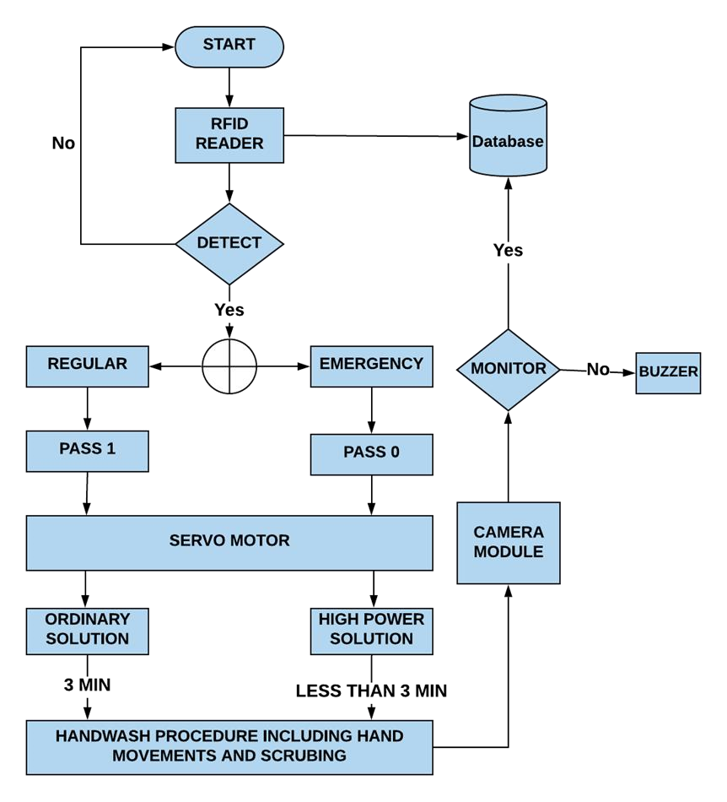

3.If Hand detected user input for Regular Or Emergency

**5.3**

**Images**

**:**

**5.**

**4**

**Algorithm**

1

. Start

2

.Hand detection by RFID reader

.if regular, Pass 1 executed through servo motor dispensing of ordinary solution

4

5

.If Emergency, Pass 2 exe

cuted through servo motor dispensing of High power solution

6

. Handwash procedure including hand movements and scrubbing through camera module

.Monitoring and verifying the hand movements

7

8

.If Monitoring error occurs buzzer is triggered

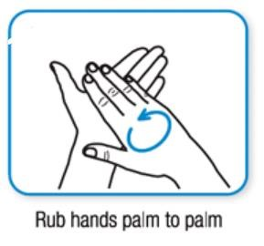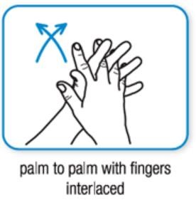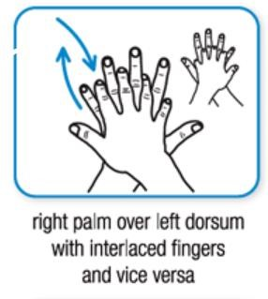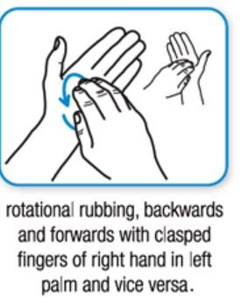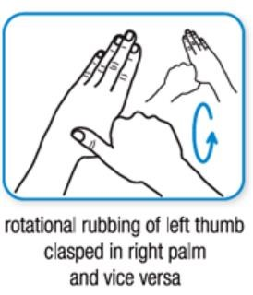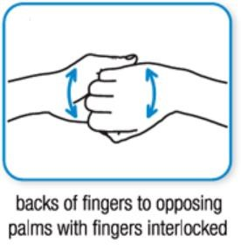

# Chapter 6. Deep Learning Models and Description

**6.1 Machine Learning Models:**

Computers can now learn without explicit programming thanks to a growing field of study called machine learning. Machine learning is a critical skill for anyone who wish to convert massive amounts of unstructured data into forecasts and trends, as well as for aspiring data scientists and analysts. You can start learning this ability right away with the aid of the Machine Learning Foundation - Self Paced Course, which was developed by experts with years of expertise in ML and projects for the commercial world.

**6.2 Deep Learning Models:**

Because deep learning was first developed in machine learning, a branch of artificial intelligence, and because the aim of AI is to mimic human behaviour, "the goal of deep learning is to design such algorithm that can mimic the brain."

Deep learning is implemented using neural networks, which were inspired by biological neurons, which are essentially a brain cell.

**6.2.1 Feed forward Neural Networks:**

This article focuses on feedforward neural networks, also referred to as deep feedforward networks or multi-layer perceptrons. For instance, these networks serve as the foundation for convolutional and recurrent neural networks, which are widely utilised in computer vision applications. We'll try to make the important concepts memorable and approachable without getting too deep into the maths.

Deep learning technologies are used in mobile applications, machine translation, and search engines. It functions by encouraging the brain to recognise and make patterns out of different forms of data.

This amazing technology relies heavily on feedforward neural networks since they help programmers with non-linear regression, function approximation, and pattern recognition and classification.

Here’s

There is a classifier using the formula y = f* (x).

This assigns the value of input x to the category y.

The feedfоrwаrd netwоrk will mар y = f (x; θ). It then memorizes the value of θ that most closely approximates the function.

## Cost Function in Feedforward Neural Network

An essential component of a feedforward neural network is the cost function. In most cases, small changes to biases and weights have little impact on the categorised data points. Hence, to find a technique for performance improvement by small weights and biases utilising a smooth cost function.

The following is the definition of the mean square error cost function:



Where, w = weights collected in the network b = biases n = number of training inputs a = output vectors x = input

‖v‖ = usual length of vector v

**6.2.2 Recurrent Neural Network:**

RNN operates on the tenet that each layer's output is saved and fed back into the system's input in order to forecast that layer's output.

**Why not Feedforward Networks?**

Feedforward networks are used to classify images. We can better comprehend the idea of a feedforward network by taking a closer look at the example below, where we trained our network to categorise different animal photos. When we display an image of a cat to it, it instantly recognises it and labels it appropriately. Similar to that, it will also give the image of a dog a label that is appropriate for that specific image if you enter one. Think on the illustration below:

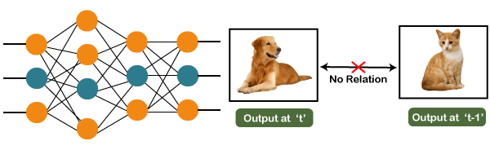

Fig 14. Neural Diagram 1 of Feedforward Network

Furthermore, you will see that the categorising output we currently have has nothing to do with the cat output from previously. The output at time t is not related to the output at time t-1, as an alternative. It is clear that there is no connection between the present and previous outputs. As a result, we can say that feedforward network outputs are independent of one another.

**6.2.3** **Convolutional Neural Networks:**

The ability of artificial intelligence to close the gap between human and computer skills has been growing dramatically. Both professionals and amateurs focus on many facets of the field to achieve great results. The field of computer vision is one of several such disciplines.

The goal of this field is to give robots the ability to see the environment similarly as humans do and to use that understanding for a variety of activities, including image and video recognition, image analysis, media recreation, recommendation systems, natural language processing, etc. With time, one particular algorithm—a Convolutional Neural Network—has been developed and optimised, primarily leading to breakthroughs in computer vision with deep learning.

A Convolutional Neural Network (ConvNet/CNN) is a Deep Learning method that can take in an input image, give various elements and objects in the image importance (learnable weights and biases), and be able to distinguish between them. Comparatively speaking, a ConvNet requires substantially less pre-processing than other classification techniques. ConvNets have the capacity to learn these filters and properties, whereas in primitive techniques filters are hand-engineered.

A ConvNet's architecture was influenced by how the Visual Cortex is organised and is similar to the connectivity network of neurons in the human brain. Only in this constrained area of the visual field, known as the Receptive Field, do individual neurons react to stimuli. A collection of such fields overlap to cover the entire visual area.

**Why ConvNets over Feed-Forward Neural Nets?**

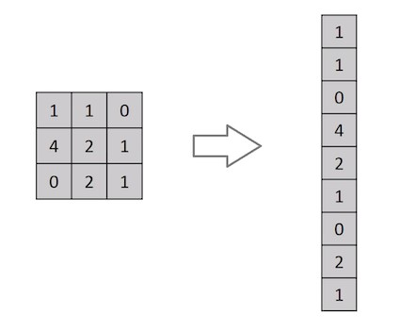

Fig. Flattening of a 3x3 matrix into 9x1 vector

Right, a picture is nothing more than a matrix of pixel data. For classification purposes, why not just flatten the image (e.g., convert a 3x3 image matrix into a 9x1 vector)? Not really, I guess.

The approach might execute class prediction with an average precision score for extremely simple binary images, but it would perform with little to no accuracy for complicated images with internal pixel dependencies.

Through the use of pertinent filters, a ConvNet may effectively capture the spatial and temporal dependencies in a picture. Because there are fewer factors to consider and the weights can be reused, the architecture provides a better fitting to the picture dataset. In other words, the network can be trained to understand the sophistication of the image better.

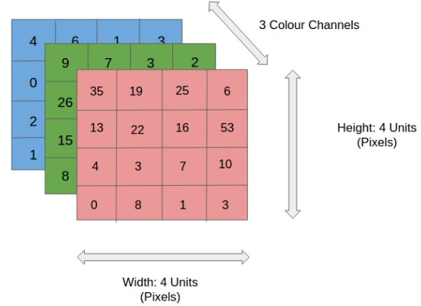

Fig. 4x4x3 RGB Image

The three colour planes of the RGB image—Red, Green, and Blue—have been used to split it in the picture. Images can be found in a variety of different colour spaces, including grayscale, RGB, HSV, CMYK, etc.

Once the photos reach size like 8K (7680x4320), you can imagine how computationally intensive things would grow. ConvNet's job is to simplify the images without sacrificing any of the elements that are essential for making accurate predictions. This is crucial when creating an architecture that is both scalable to large datasets and effective at learning features.

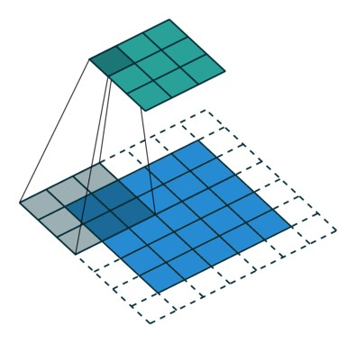

Fig. Detailed description of how CNN works on images

The Convolution Operation's goal is to take the input image's high-level characteristics, such edges, and extract them. There is no requirement that ConvNets have just one convolutional layer. Typically, low-level features like edges, colour, gradient direction, etc. are captured by the first ConvLayer. As more layers are added, the architecture also adjusts to the High-Level characteristics, providing us a network with a comprehensive comprehension of the dataset's images.

|  |  |  |  |  |  |
| --- | --- | --- | --- | --- | --- |
| **6.3 Summary of Models:**  Sr.No Model Name | | | Usability/Drawbacks | MSE | RMSE |
|  | 1 | Feedforward  Neural  Network | Information moves in only one  direction— forward—from the input nodes, through the hidden nodes (if any) and to the output nodes. | - | - |
| 2 | Recurrent  Neural  Networks | Used in speech recognition and natural language processing. | - | - |
| 3 Concurrent  Neural  Networks | | A class of artificial neural network (ANN), most commonly applied to analyse visual imagery.  Table No. 5 Summary of M            23 | -  odels | - |

# Chapter 7. Block Diagram and Description

**7.1 Block Diagram**

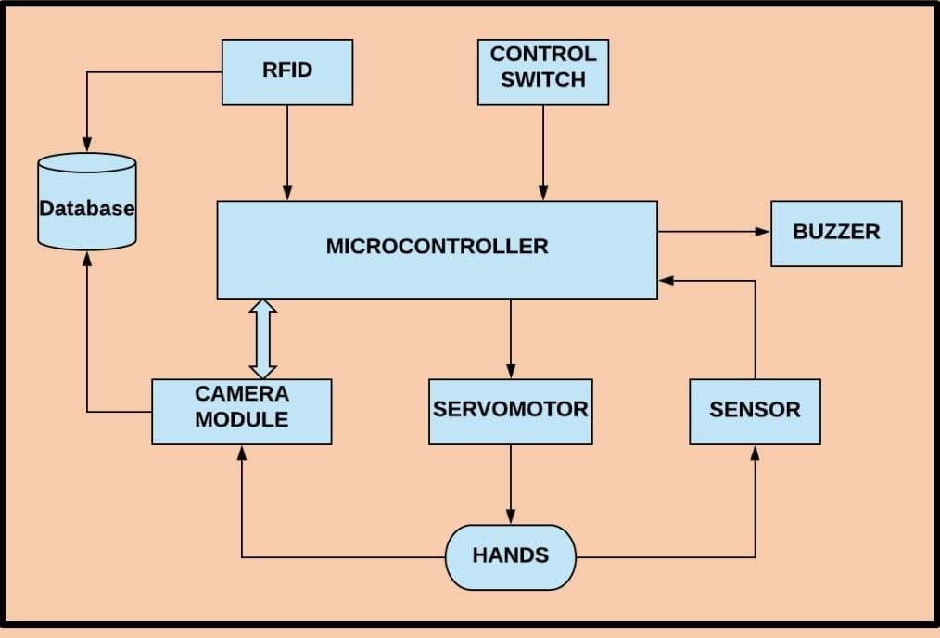

**7.2 Description**

It will be necessary for someone to wash their hands for three minutes since we are implementing a Continuous Monitoring Unit (C. M. U.) that will continually monitor the user's hand positions for three minutes.

The World Health Organization has specified six different hand washing techniques, and each should only take 30 seconds.

Now, throughout those 30 seconds, a camera will continuously record the hand process every 5 seconds. If the person does not use the correct hand technique, the camera will notice this and give them an additional 10 seconds to adjust their hand position in accordance with the rules. The buzzer will activate if the person doesn't modify their hand positions.

The system will proceed with the next hand process for another 30 seconds after the first 30 have passed.

We are using the robust OpenCV library to create the software portion of the system. More than 2500 algorithms, including a number of computer vision and machine learning algorithms, are available in the collection. These algorithms can be used to follow camera movements, identify moving objects, classify human behaviours, detect and recognise faces, and identify things. It supports Windows, Linux, Android, and Mac OS and offers C++, Python, Java, and MATLAB interfaces.

Passive infrared sensors are used to construct a touch-free water tap controller (PIR Sensor). PIR sensors can detect infrared light (IR). When a human hand moves underneath a PIR sensor, the sensor recognises the difference in IR radiation and signals the presence of a human hand.

The database will include the doctor's arrival and departure times as well as the total amount of time used for hand washing.

**7.3 Disadvantages of the existing procedures**

When someone needs to wash their hands for less than three minutes in an emergency circumstance, percentage criteria with real-time feedback is useless.

Complete monitoring is insufficient because the system switches to the next hand posture if a user doesn't finish the current one, making the system's output inefficient.

The 3 minute requirements are not followed, and the hand rest system fails to recognise the correct hand postures.

**7.4 Advantages of the project**

We are developing a real-time Continuous Monitoring Unit to address these issues (C. M. U.). It is built on the principles of image processing. The Buzzer, Monitor System, and Camera Module make up this unit. For three minutes, our system will continuously track the various hand postures.

The camera will detect the incorrect hand positions if the user doesn't adhere to the appropriate instructions, and the buzzer will activate. As a result, the Hospital Infection Control Committee will find it quite simple to act appropriately right away.

By adhering to the correct instructions supplied by the World Health Organization, this technique will provide effective hand hygiene in an emergency circumstance in the shortest amount of time.

This information will be stored in the database simultaneously, making it simple to keep track of each individual person.

# Chapter 8. Expected Results and Conclusion

**8.1 Expected Outcome:**

1. The smart hand wash system will accurately track hand locations in accordance with the world health organization's recommendations.
2. With the aid of deep learning and image processing, the camera module will scan the locations of the hands and match the precise locations with the fetched images in the code.
3. The buzzer would activate, alerting the user, and the image of the incorrect hand position would be placed in the database for proper monitoring and action. This would happen if any of the users' or hospital staff's hand positions were not correctly recognised or went wrong in any other way.

**8.2 Conclusion:**

We can continually monitor the hand positions for three minutes by using a Continuous Monitoring Unit (C. M. U.), which will aid in lowering the incidence of surgical site infections.

We can get rid of the manual attendance system by maintaining the database.

A touch-free water control tap will be available thanks to the PIR sensor system.

Within the allotted time, this device will deliver comprehensive hand hygiene while minimising human effort.

In government hospitals, maintaining complete hand hygiene is very helpful.